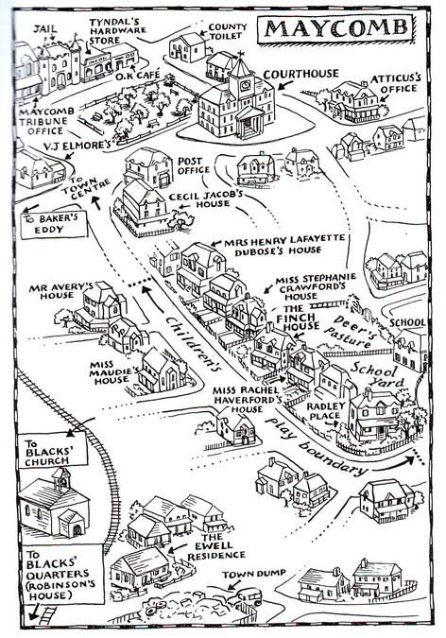
Specific Setting of Maycomb. (n.d.). Retrieved December 01, 2016, from http://10goldmockingbird.wikispaces.com/Specific+Setting+of+Maycomb

